1. What class did the Create and Edit Course page models derive from? Why?

They Derived from DepartmentPageModel because they both will use the select list of department names making it more efficient for them to derive from the base class than remaking it for each page model.

1. Do a screen print demonstrating the revised Course Create functionality for department name.

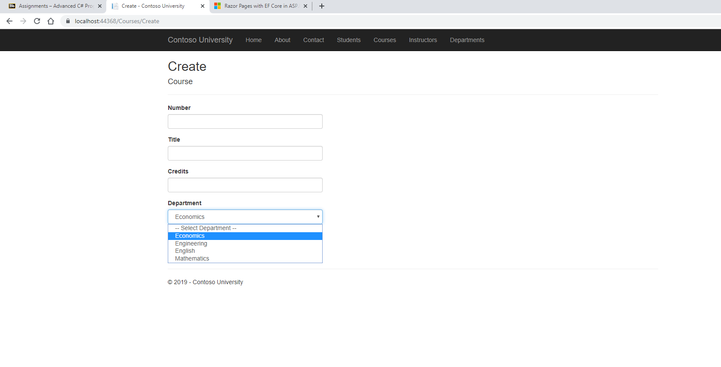

1. Do a screen print demonstrating the revised Course Edit functionality.

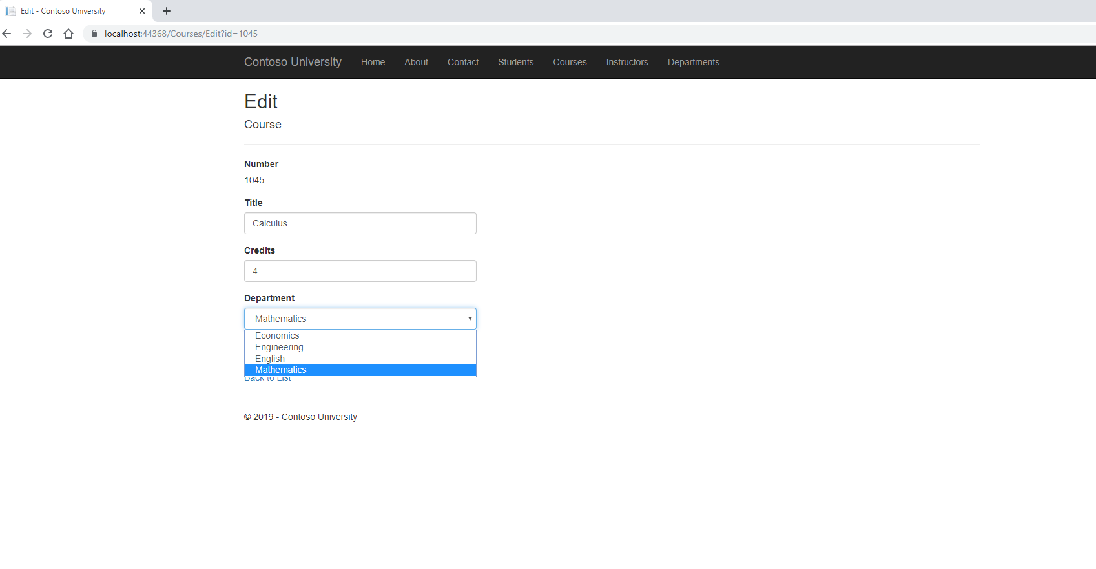

1. Do a screen print demonstrating the revised Course Delete functionality.

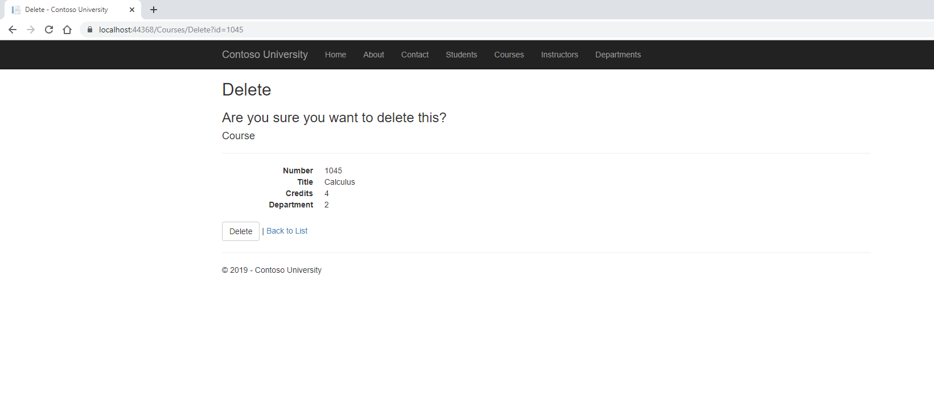

1. Do a screen print demonstrating the revised Course Details functionality.

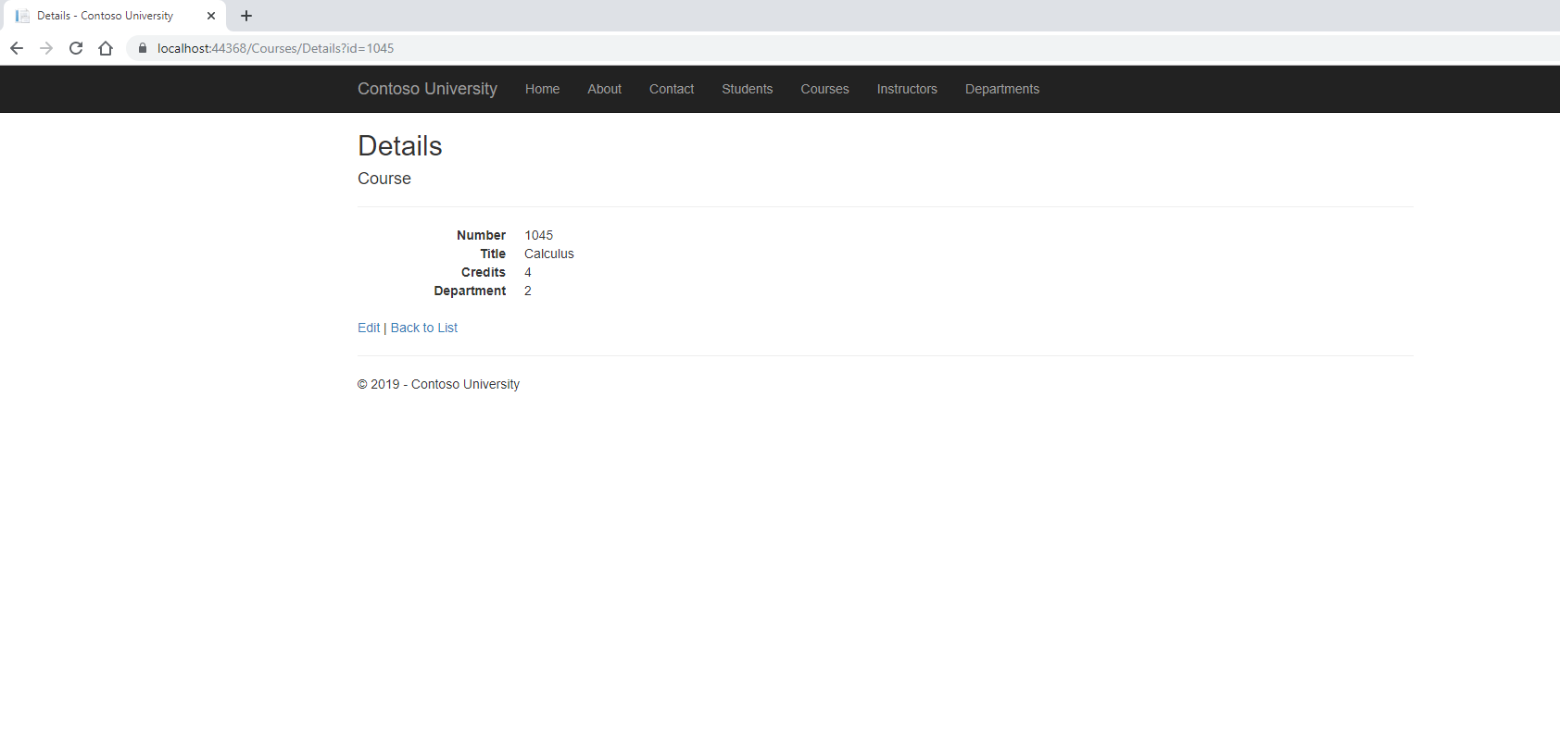

1. Do a screen print demonstrating the revised Instructor Edit functionality for office location.

Before: 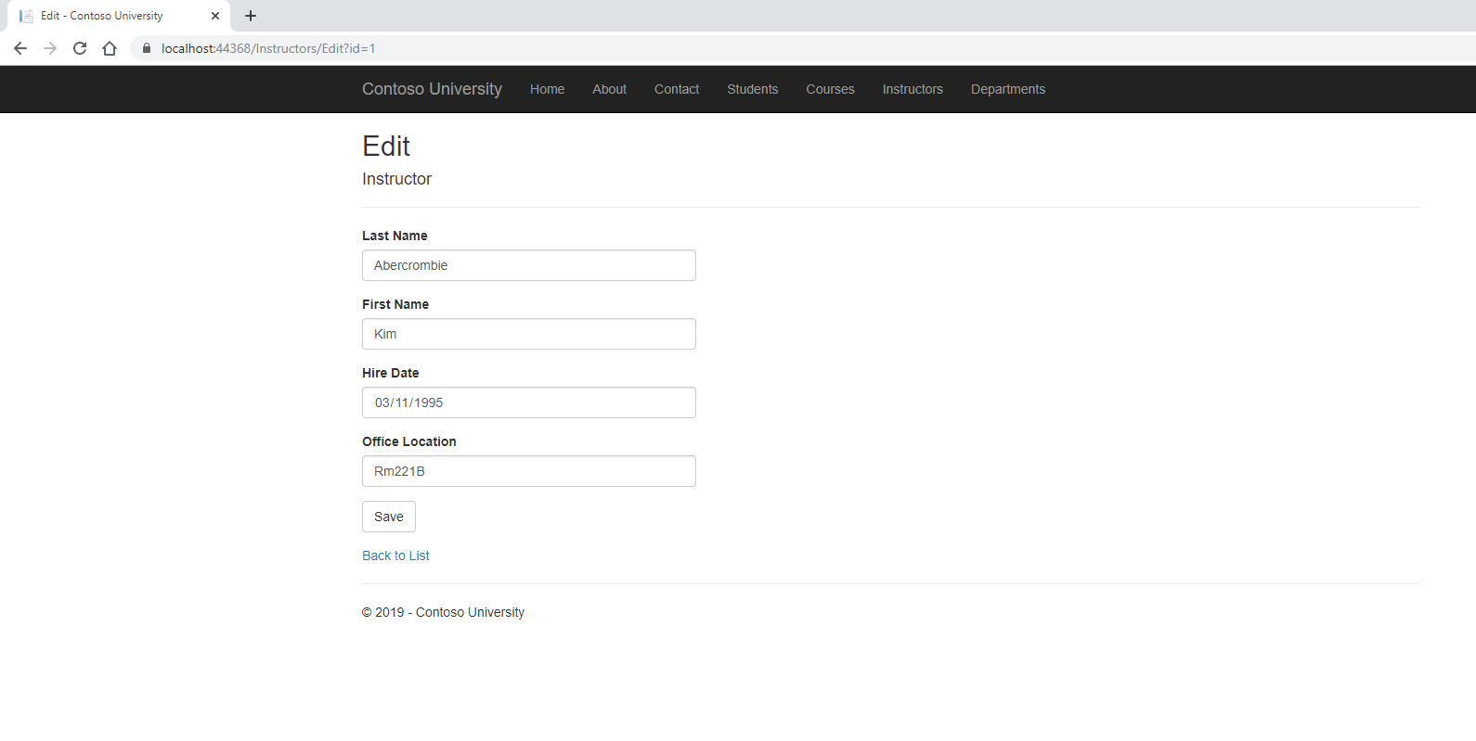

After: 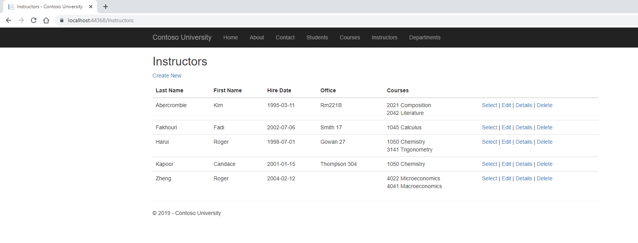

1. Do a screen print demonstrating the revised Instructor Edit functionality for course assignments.

Before: 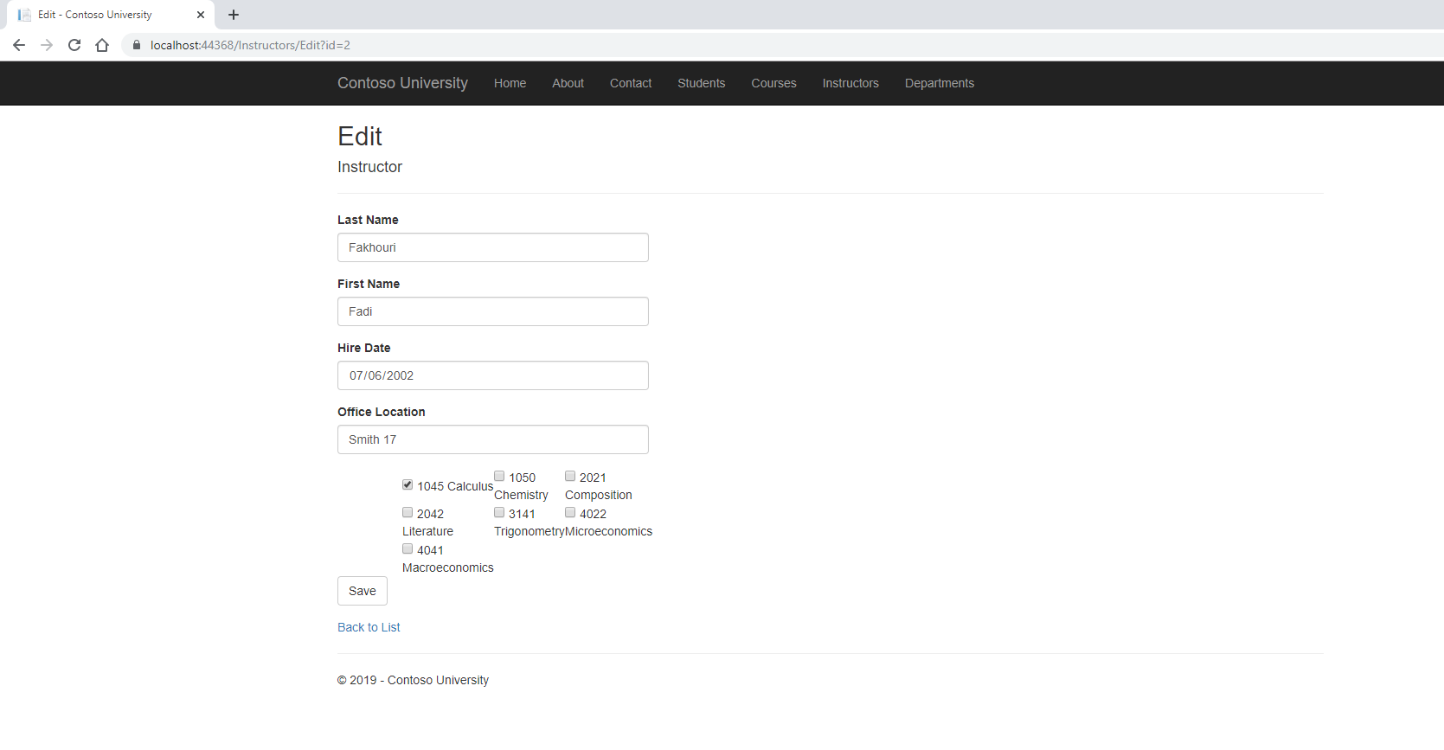

After: 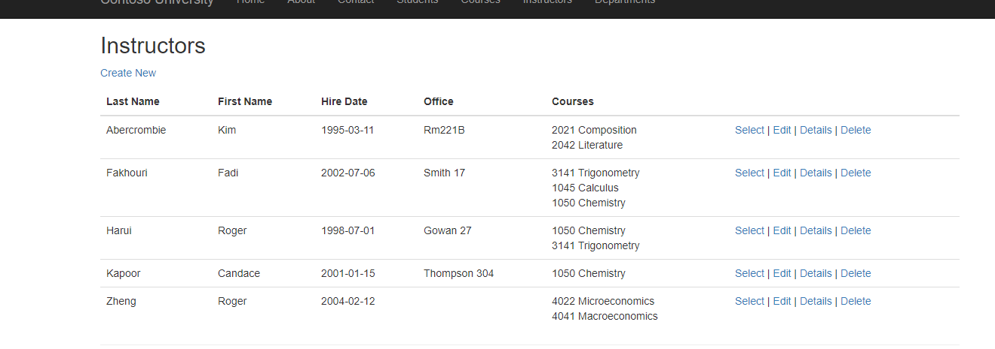

1. Do a screen print demonstrating the revised Instructor Create functionality for office location and courses.

Before: 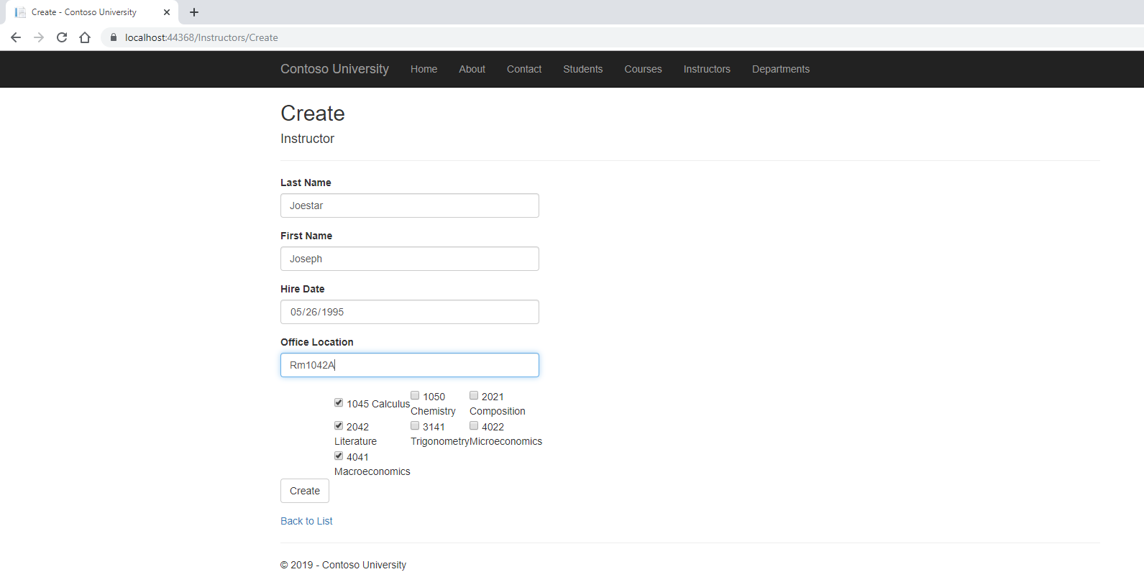

After: 